Speech Processing Lab Assignment – 3

Name: Paruchuri Sai RegNo: BL.EN.U4AID23063

Experiment-1: Fourier Transform and Short-Time Fourier Transform

Experiment-2: Energy Distribution in Vowels and Consonants

Dataset Description: The speech file is taken from LJ Speech Dataset from Kaggle website which contains short audio clips of speakers reading passages from books. The speech has 9 seconds duration.

Objective: The objective of this assignment is to understand and apply the Fourier Transform (FT) and Short-Time Fourier Transform (STFT) to analyze speech signals using Python and to analyze and compare the energy distribution of vowels and consonants in speech signals using Python.

Code and Output:

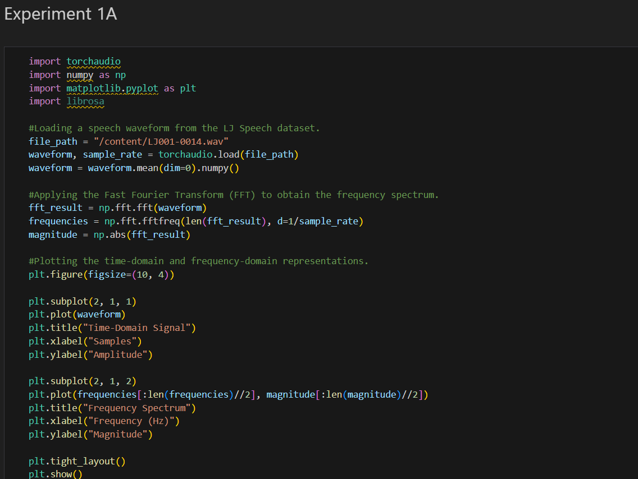

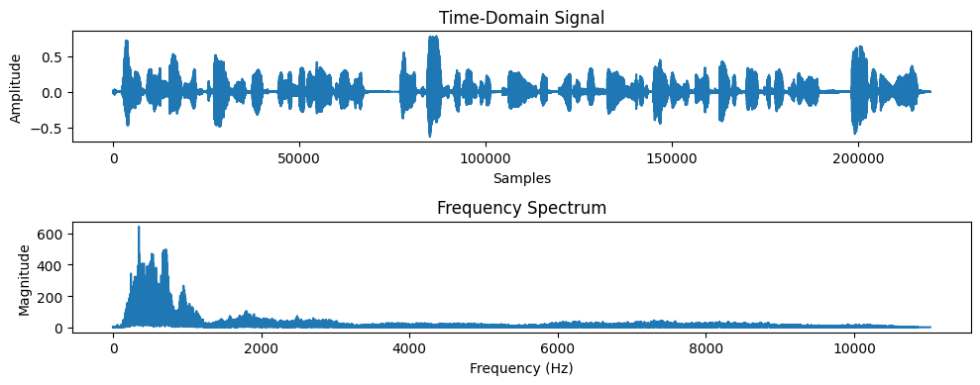

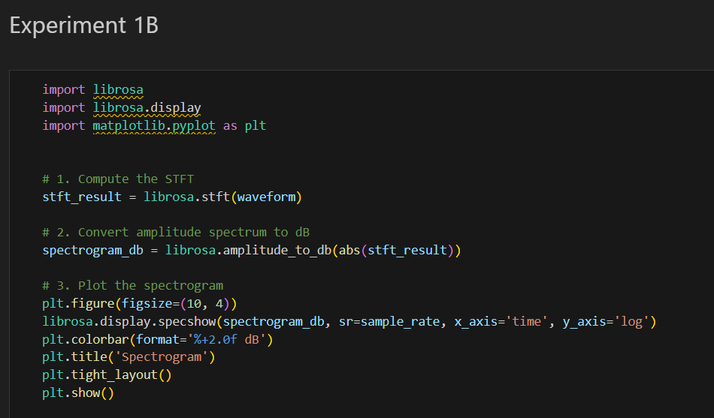

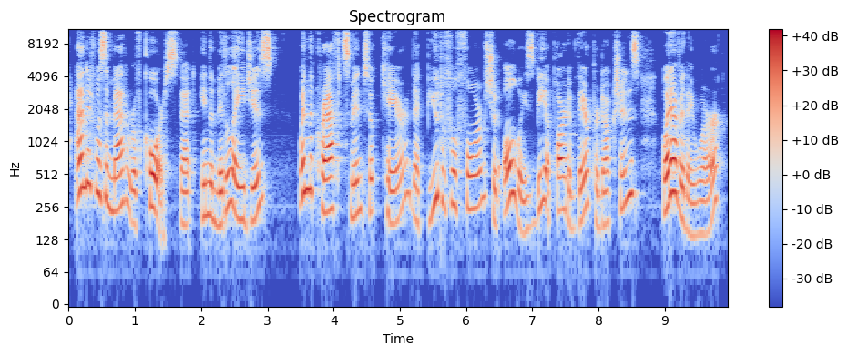

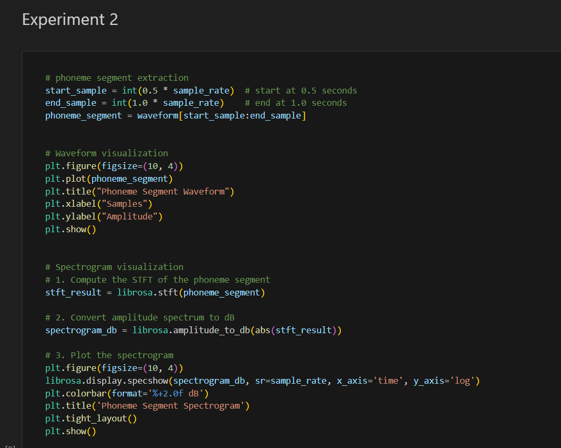

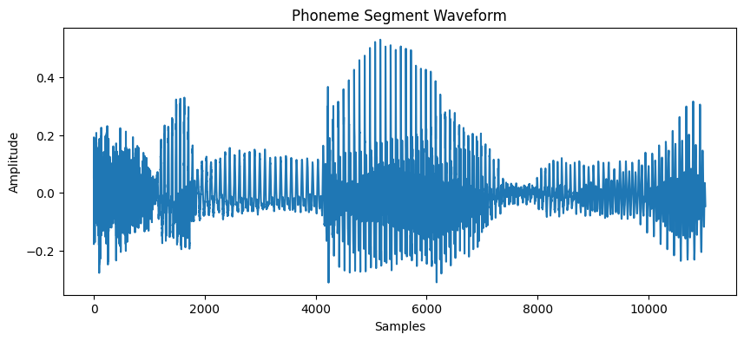

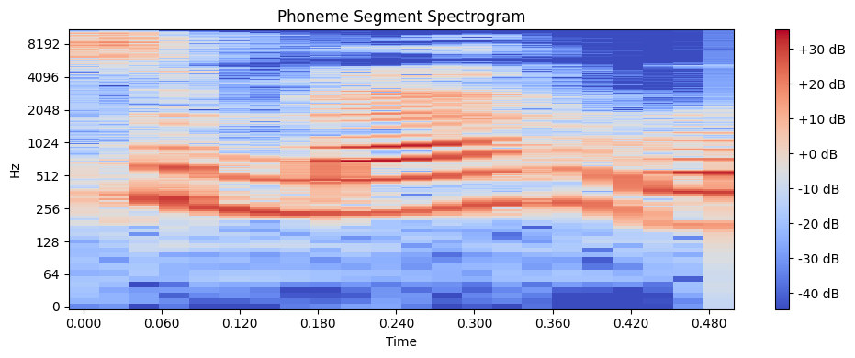

Conclusion:

We have seen in this assignment how to apply fourier transformation and short-time fourier transformation to analyze speech signals and also to visualize frequency components over time.In experiment 2 we have seen how to analyze and compare energy distribution of vowels and consonants and seen energies of phonemes in different frequency ranges.

GitHub code Link:

https://github.com/SaiParuchuri123/Speech_Processing